WEB APP STORE

## A PROJECT REPORT

***Submitted by***

# Aastha Goyal (201500004)

**Divyanshi Varshney (201500233)**

# Anikate Agrawal (201500088)

***in partial fulfillment for the award of the degree of***

# BACHELOR OF TECHNOLOGY IN

## Computer Engineering and Application



**GLA University, Mathura**

NOV 2022

# BONAFIDE CERTIFICATE

Certified that this project report **“WEB APP STORE”** is the bonafide work of “**Aastha Goyal, Divyanshi Varshney, Anikate Agrawal”** who carried out the project work under my supervision.

|  |  |
| --- | --- |
| **SIGNATURE**  **Dr. Rohit Agrawal**  **HEAD OF THE DEPARTMENT**  Department of Computer Engineering & Application | **SIGNATURE**  **Ms. Pragya Singh**  **SUPERVISOR**  Technical Trainer  Training & Development Department |

Submitted for the project viva-voce examination held on

**INTERNAL EXAMINER EXTERNAL EXAMINER**

# ACKNOWLEDGEMENT

It gives us the immense pleasure to present the report of the B.Tech. Mini Project undertaken during B.Tech. 3rd Year. This project would never have seen the light of the day without the help and guidance that we have received.

Our heartiest thanks to **Ms. Pragya Singh, Technical Trainer (T&D Department)** for providing us with an encouraging platform to develop this project, which thus helped us in shaping our abilities towards a constructive goal.

We owe special debt of gratitude to **Mr. Pankaj Kapoor**, for his constant support and guidance throughout the course of our work. He has showered us with all their extensively experienced ideas and has also taught us about the latest industry-oriented technologies.

We also do not like to miss the opportunity to acknowledge the contribution of all faculty members of the department for their kind guidance and cooperation during the development of our project.

**Divyanshi Varshney (201500233)**

**Aastha Goyal (201500004)**

**Anikate Agrawal (201500088)**

# TABLE OF CONTENTS

## List of Figures Abstract Graphical Abstract Abbreviations

**Chapter 1. Introduction**

* 1. Identification of relevant Contemporary issue
  2. Identification of Problem
  3. Identification of Tasks
  4. Timeline
  5. Organization of the Report

## Chapter 2. Goals and Objectives

* 1. Problem Statement
  2. Goals and Objectives

## Chapter 3. Design Flow

* 1. Hardware & Software Requirements
  2. Project Design

## Chapter 4. Implementation & Validation

4.1 Implementation

## Chapter 5. Conclusion And Future Work

* 1. Conclusion
  2. Future Work

**References**

# List of Figures

## Figure 3.1 Our Platform

**Figure 3.2 Header with Navigation bar Figure 3.3 Home**

## Figure 3.4 App Section Figure 3.5 Games Section Figure 3.6 E-Books Section

**Figure 3.7 Image Carousel showing Features Figure 3.8 Footer**

# ABSTRACT

Web Development is the ability to develop websites and user-friendly web applications. After learning Html, CSS and Javascript we made up a variety of small web applications to do various tasks. Here came the need of a website where we could display our applications and make them easily available for our users. We needed a user interface through which user could easily interact and access the applications he needs so we came up with an idea of developing a **Web-App Store**.

**Web-App Store** will be one place for all our past, present and future web developments. It will excellently showcase our skills, help us to keep record of our developments and help in their better maintenance.

With this idea in our thoughts, we chose **Web-App Store** as our mini project and hope we shall be successful in accomplishing it.

# GRAPHICAL ABSTRACT

Sign Up

E-Books

Login

**Web App**

**Store**

Games

Home

Apps

**ABBREVIATIONS**

* + 1. HTML Hyper Text Markup Language
    2. CSS Cascading Style Sheets
    3. JS JavaScript
    4. IT Information Technology
    5. UI User Interface
    6. VS Visual Studio
    7. RAM Random Access Memory

# CHAPTER 1 INTRODUCTION

## Identification of relevant Contemporary issue

* + - No Platform available for displaying web applications for free. There were several web applications that needed to be showcased on a page for users to use.
    - Without a User Interface Clients will not be able to reach web applications.
    - A good website with user friendly interface leads to higher number to clients.
    - Major IT Companies have their own platform to showcase their applications like Google Playstore to enhance security and prevent content from being copied.

## Identification of Problem

Need For Authentic Secure Platform To display applications and provide User Interface for our clients and users to access content.

## Identification of Tasks

There are several tasks that need to be performed:

* Gathering of all requirements and features required in the website
* Analysing requirements and feasibility study
* Planning and creating appropriate model
* Making initial design of website
* Implementation of Design and Coding
* Testing of website and apps
* Error Detection and Handling

## Timeline

August 1-30 Requirement Specification, Built up Model September 1-30 Designing of Website and User Interface October 1-30 Implementation started. Built Apps and website. November 1-20 Completed Project. Testing. User Review.

November 21-25 Project Presentation and Report Submission.

## Organization of the Report

Chapter 1 gives the introduction to the project specifying the need of the project, various problems which would be solved through the project and the various tasks required to be performed for completion of the project. It also tells the timeline of various activities performed.

Chapter 2 specifies the problem statement and the goals and objectives of the project.

Chapter 3 gives details about the model and design of the project. Various constraints are also discussed here. It gives the structure of the website. It provides all the details about each section provided in the website.

Chapter 4 talks about how the design is implemented using various technologies. Chapter 5 concludes the project and gives the future scope.

# CHAPTER 2

## GOALS AND OBJECTIVES

* 1. **Problem Statement**

A fully Responsive website having authentication, header with navigation bar, home, apps, games, e-books, and footer required.

## Goals and Objectives

There are several goals:

* + 1. A Website to showcase various web creations.
    2. A platform that works well on all devices such as mobiles, laptops etc.
    3. User Friendly User Interface.
    4. Secure Platform
    5. Ease Of User Feedback
    6. Several Applications for users
    7. Entertaining Games for children
    8. Interesting E-Books for Students and Readers
    9. Prevention of unauthentic usage.

# CHAPTER 3 DESIGN FLOW

## Hardware & Software Requirements

* + - HTML, CSS and JAVASCRIPT
    - VS CODE
    - Google Firebase
    - Version Control and Hosting: GitHub
    - Processor: i5 or above
    - Minimum 4GB RAM
    - Windows Operating System

## Project Design

The website has various sections such as: -

1. Header
2. Home
3. Apps
4. Games
5. E-Books
6. Features
7. Footer.

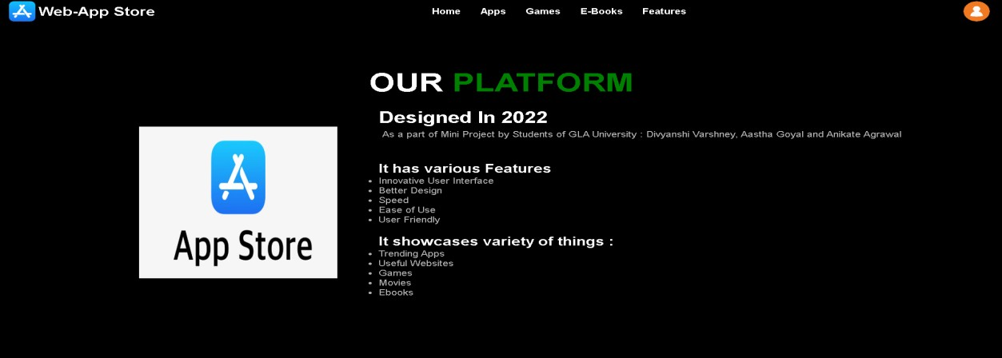

**Fig. 3.1 Our Platform**

The roles of the sections are as follows:

**Header:** This contains our Web-App Store logo, Navigation Bar, and button for Sign-In and Login-In.



**Fig. 3.2 Header with logo and Navigation bar**

**Home:** It has our homepage banner and some text which introduces the user to our website. After this there is a short description of our platform.

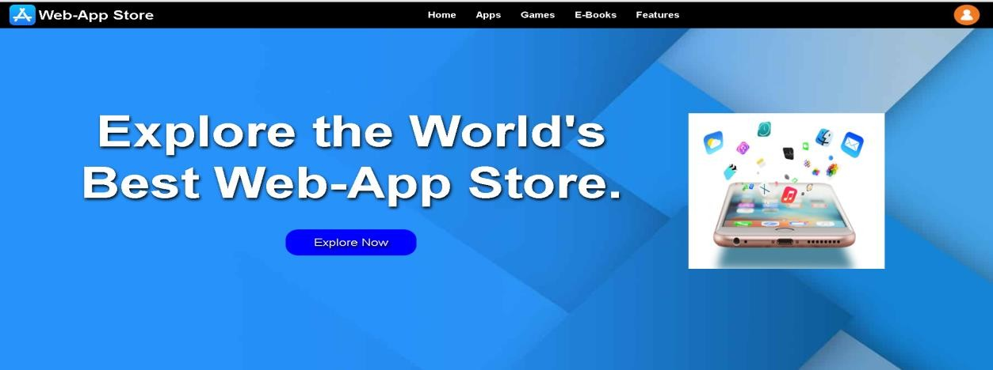

**Fig. 3.3 Home**

**APPS:** This section has cards showcasing all our own made web applications. They provide a way to the user to click and navigate to those app pages. All the apps displayed are made by us and are present at different locations this section serves as a link to those apps.

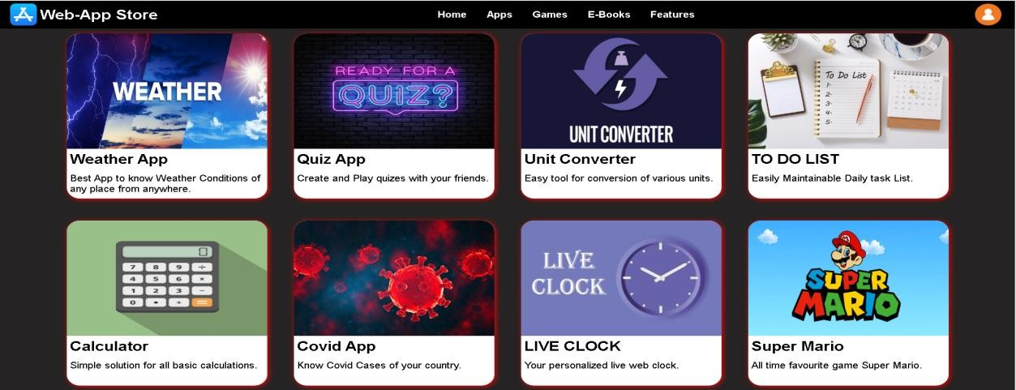

**Fig. 3.4 App Section**

**Games:** Like the app section this section has links to various online web games which serve as a nice fun-time for our users. Any game they want to play just click and they will reach their destination.

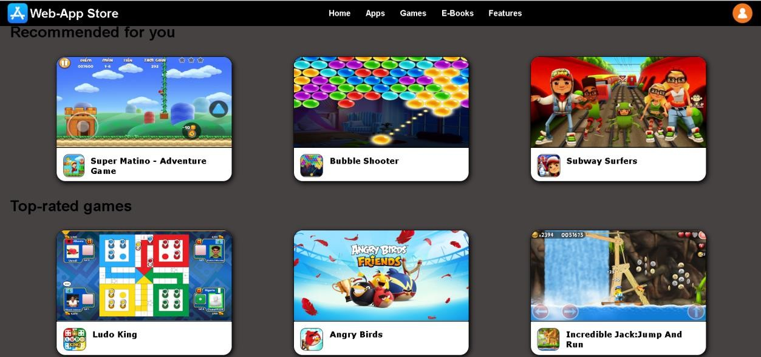

**Fig. 3.5 Games Section**

**E-Books:** For all the readers our website has a variety of all-time famous e-books. Which our users can easily download and use for free.

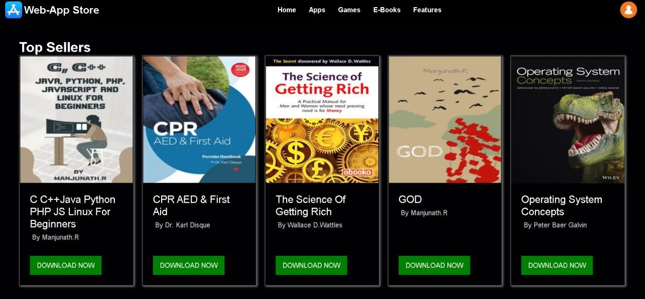

**Fig. 3.6 E-Books Section**

**Features:** This has an image carousel displaying our website features.

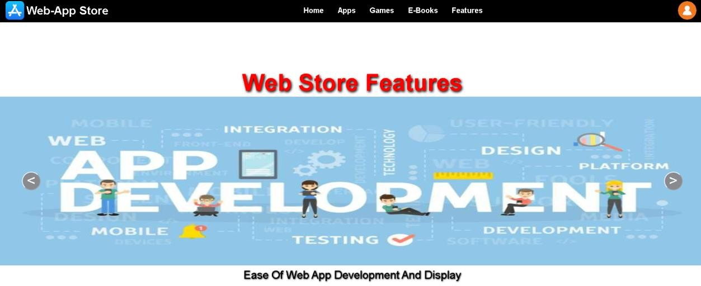

**Fig. 3.7 Image Carousel showing features**

**Footer:** Last but not the least there is a footer section to display our details and for feedback.

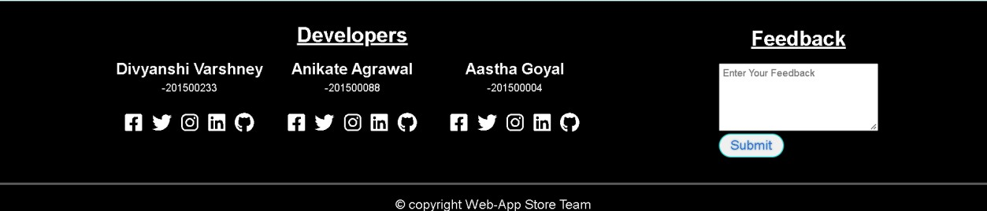

**Fig. 3.9 Footer**

# CHAPTER 4 IMPLEMENTATION AND VALIDATION

## 4.1 Implementation

**Frontend**

For the frontend we are using HTML and CSS, with some Bootstrap. To make the frontend more reactive and user interactive we will use JavaScript.

## Backend

In the backend we are using Google Firebase to handle all database and other backend needs.

## HTML

Hyper-Text-Markup-Language is used for structuring web pages over the internet. HTML is the language in which most websites are written. HTML is used to create pages and make them functional.

## CSS

Cascading-Style-Sheet is a styling language used to style and basically define how the content will appear on the website.

## JavaScript

JavaScript is a scripting or programming language which is now used extensively to design modern web applications and website, it allows the developer to write application which modify themselves according to each user and its data, this made web applications much more accessible and suitable for many purposes. Many Frameworks of JavaScript such as React, Node, Next etc. are used for different type of requirements and developments.

## Google Firebase

Firebase is an app development platform that helps you build and grow apps and games users love. Backed by Google and trusted by millions of businesses around the world. Firebase provides detailed documentation and cross-platform SDKs to help you build and ship apps on Android, iOS, the web, C++, and Unity.

# CHAPTER 5 CONCLUSION AND FUTURE WORK

## Conclusion

The Website is successfully designed and is live on GitHub. It is also fully responsive to work well on all devices. Login and Sign Up are working fine. Header Section has a working navigation bar to navigate to different section.

All the apps in the app section are running nicely. They lack certain responsiveness due to lack of time. Slight Security issues possible in them as apps are on different locations from the authenticated website.

Games and E-Books are up to the mark. Right now, they are limited in number but are useful enough.

Footer Section with feedback form is fully functional.

## Future work

In the Future the website needs a backend server to store all the content of our webpage and render it dynamically on the website. So that we can have any number of applications, games and e-books displayed just by adding them to the database. For login more options need to be provided like google and Facebook accounts. After login, a profile section must be created to store user details like address and mobile number.

Apps need updates and maintenance for improvement.

# REFERENCES

* + 1. **Books:** Black Book HTML5, CSS, JS

## Websites:

* + - 1. MDN Web Docs
      2. W3Schools
      3. GeeksForGeeks
      4. Javatpoint
    1. **Faculty:** Ms. Pragya Singh (Technical Trainer in GLA University)
    2. **GitHub Repository link:** [**https://github.com/anikateagrawal/Mini-Project**](https://github.com/anikateagrawal/Mini-Project)
    3. **Live Website Link:** [**https://anikateagrawal.github.io/Mini-Project/**](https://anikateagrawal.github.io/Mini-Project/)